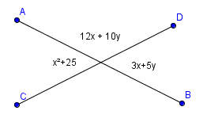

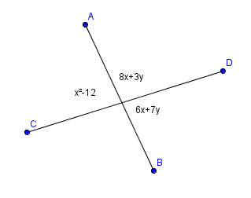

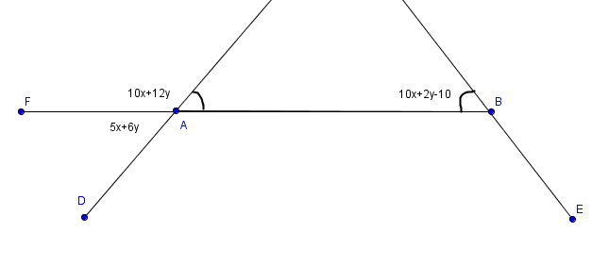

8. (13 pts) Fill in the blanks to the proof below. 

Given: KH bisects 

Prove: 

|  |  |
| --- | --- |
| **Statements** | **Reasons** |
|  |  |
|  | Definition of an Angle Bisector |
|  | Definition of Linear Pair |
|  |  |
|  | Transitive Property |
|  |  |
|  |  |

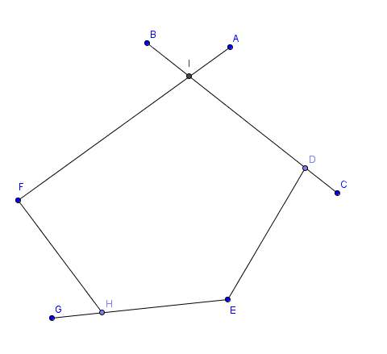

Given: <BIA = 90, <CDE = 70, <GHF = 60, <E = 120

Prove: < F = 100