**Unit 1 Review Guide**

**For 1-5, state whether the statement is *true* or *false*. If FALSE provide a counterexample.**

1. The ray from point *R* through point *P* and point *Q* is named as  or .

2. The line segment from point *P* to point *Q* can only be named as .

3. If two angles are supplementary, then they are always a linear pair.

4. If intersects  at point *P*, then  and  are a pair of vertical angles.

5. If two lines never intersect, then they are parallel.

6. If point *B* is the midpoint of , and  and . Find AC.



7. If is the angle bisector of , BE is the angle bisector of , and the m= 16º, What is the measure of ?

8. If four times the measure of an angle is equal to five times the measure of its complement, find the measure of each angle.

9. Draw points B, A, G, E, L such that points A, G and E are collinear and angles BAG and LEG were congruent.

10. Draw two line segments using three points but without a midpoint.

11. Draw an isosceles triangle marking that two sides and the angles opposite those sides are congruent.

12. Solve for x. 13. Find the measure of the hands of a clock at 9:30

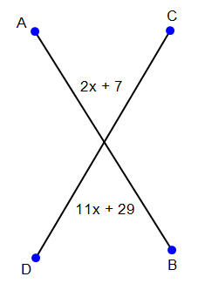

14. M is the midpoint of . If  and , find the length of .

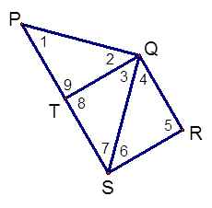15. What do we call a basic math assumption that does not require a proof? _______________________________

16. Use the figure to the right to answer the following questions.

1. If , which angles must be complementary?

_________________________

1. If  and  find the measure of *x*

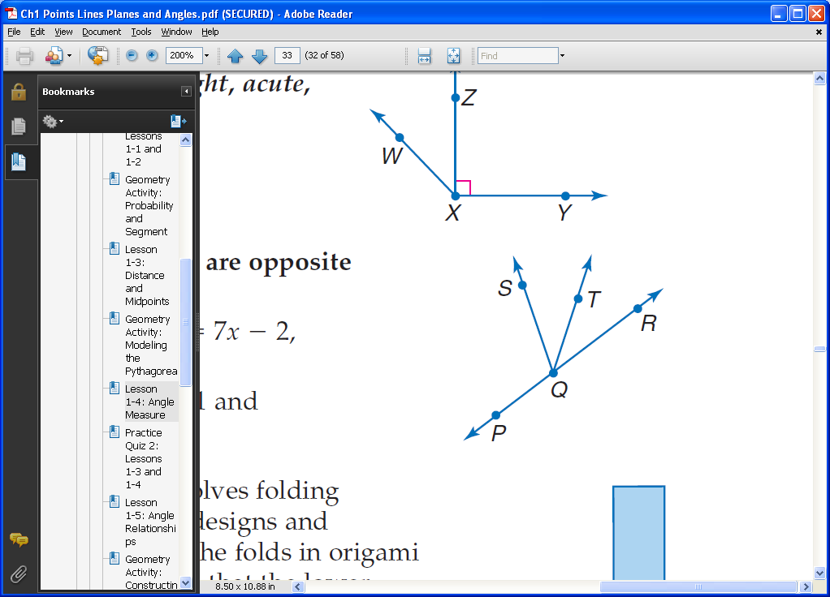17. In the figure,  and  are opposite rays, and 

bisects . Find the measure of if

 and 

18. Make sure you know the following vocabulary. You will not need to define these words from scratch, but you need to know what they mean: collinear, coplanar, opposite rays, partition, polygons from quadrilateral to dodecagon, vertical angles, linear pairs, complementary, supplementary, skew lines, postulate, theorem.

19. Write the equation of line through the points (-11, 22) and (-8, 10) in point-slope and slope intercept form.

20. Write the equation of a line through the point (25, 37) and perpendicular to the line through the points (13, 47) and (5, 63) in slope-intercept form and standard form.

21. Ray PJ starts at the intersection of y1= 4x – 17 and y2= 13 -11x. Find the coordinates of point P.

22. Solve for x. 17 - 3|2x – 4| = -13 5|8x| - 2 = 38

23. Find the midpoint of segment NL given N(22/7, 5) and L(13/2, -5/3).

24. On a map, the coordinates of triangle F(-7, 7), U(1, 7) and N(1, -8) represent a park. Is this an accurate representation of a park that has a perimeter of 480 yards and area of 720 yards?

25. Find the perimeter and area of rectangle G(-3. 4), I(1,4), R(-3, -2), L(3, -2). Also, find the midpoint of each side.

26. Find the perimeter and area of triangle F(-7, 2), I(-5, 9) N(2, 7).

27. Find the sum of the interior angles of a:

a) undecagon b)septagon c) 41-gon

28. Simplify. 

29. Prove.

Given: 

Prove: 

|  |  |
| --- | --- |
| **Statements** | **Reasons** |
|  |  |
|  |  |
|  | Addition Property of Equality |
|  |  |
|  |  |

30. Challenge: Find the area of the triangle with vertices (-3,3), (7, 5) (9, 12)..