**Geometry Unit 1 Review Guide**

1. 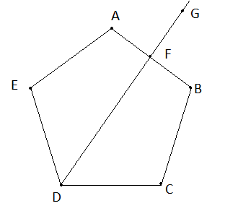Mark the figure on the left to show the following:
   1. Ray DF is a bisector of angle EDC
   2. F is the midpoint of segment AB
   3. Angle AFG is a right angle
2. Write the following in symbolic form:
   1. Line AB
   2. Ray DF
3. What is another name for ray DF?
4. What are two more names for angle C?
5. 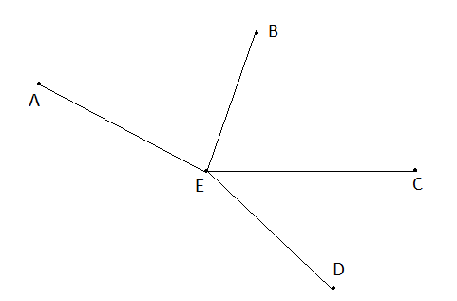For the figure on the left, Ray BE bisects Angle AEC. Angles BEC and CED are complementary. If Angle DEC is 28 degrees, find the measure of the other two angles. Also, name a side of angle BEC.

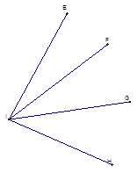

1. For the figure on the left, if segment FI bisects angle EIG, and the measure of angle EIG is 70 degrees and the measure of angle EIF = 5y + 10, find y.

1. If B is the midpoint of segment AC and AB = 3x + 2 and BC = 6x – 7, then find x.
2. Find the midpoint of a line with endpoints (1, -3) and (12, 8)
3. Find the endpoint of a line endpoint (-2, -3) and midpoint (-5, -8)
4. Find the other endpoint of a line segment with a midpoint of (5, 5) and endpoint (12, -13)
5. Write the symbol notation for the following figures:
6. Line AB d) Angle NAS
7. Ray BC
8. Segment DF
9. Sketch and label AB || DC. 16. Sketch and label 

