Name:_________________________________________________________________________ Period:_______

Geometry Honors Final Exam Review Guide

1. Classify the triangle (by sides and angles) given three side lengths.

a. 5, $2\sqrt{3}$, 8 b. $6\sqrt{2}, 3\sqrt{2}$, 3 $\sqrt{10}$ c. 4, $\sqrt{16}$, 2 $\sqrt{4}$ d. 9, 11, 10

2. The area of each semicircle is 8π. Find the perimeter of the figure as an exact answer.



3. Find the measure of angle J.

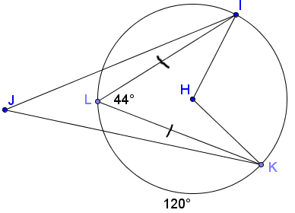

4. Find the area of the trapezoid.

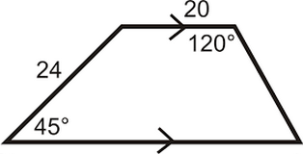

5. Using the picture in problem 3, given HK = 4 in, find the length of arc JK in terms of pi.

6. Find the volume of the figure given it is an equilateral triangular prism where each side is 4 cm, the height is 10 cm, and the cylinder missing in the middle has a radius of 1 cm to the nearest cubic cm.

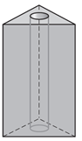

7. An arc has a measure of 15π/4. The arc is intercepted by a central angle with measure 3π/2 radians. What is the length of the radius of the circle?

8. What is the surface area of a sphere given its volume is 98π/6?

9. Find the area of a circle where a chord that is 50 cm is 7 cm from the center of the circle.

10. Find the measure of angle O.

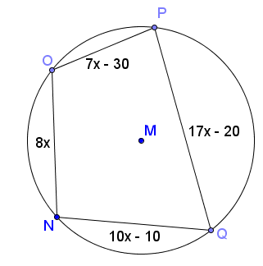

11. The volume of a cube is 64 cm3. Find the surface area.

12. A cone has radius of 8 and slant height of 17. Find the volume.

13. A trapezoid has height 12, base lengths 14 and 20. What is the length of the midsegment of the trapezoid?

14. Convert the following from degrees to radians.

a. 170o b. 265o c. 12o

15. Convert the following from radians to degrees.

a. 2π b. c.

16. The volume of the cube is 125 in3. Find the length of the long diagonal.

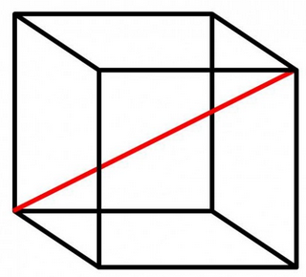

17. Classify the triangle with vertices (-2, 4) (-3, 3) and (1, 0).

18. Find the equation of a circle with a diameter that has endpoints (-3, 10) and (5, -4).

19. Find the measure of each angle.

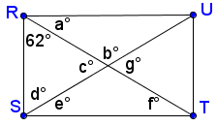

20. Find the area of the shaded region as an exact answer.

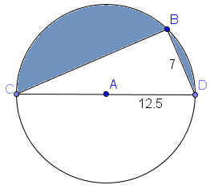

21. Find the area of the shaded region as an exact answer.

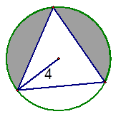

22. A square pyramid has side length 8 and surface area 56 in2. Find the volume.

23. Find the length of side x

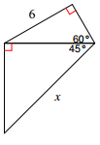

24. Find the measure of each interior angle and each exterior angle for a regular:

a. Pentagon b. Hexagon c. Heptagon d. Octagon

25. Find the area of a triangle with vertices (-2, 4) and (7, 2) and (3, 4).

26. Find the length of arc AC in terms of pi given AC = 5 in.

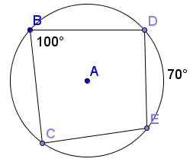

27. Given ABCD is a parallelogram, find the coordinates of point D in terms of a, b and or c.

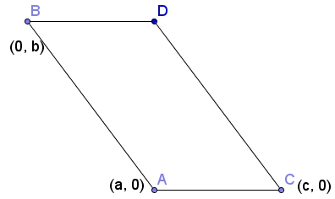

28. A wheel has a radius of 13 inches. How many revolutions does it make to drive 300 feet?

29. Given ABCD is similar to EFGH, ABCD has an area of 81 and EFGH has an area of 64. What is the ratio of their perimeters? What is the ratio of their side lengths?

30. Find the value of x.

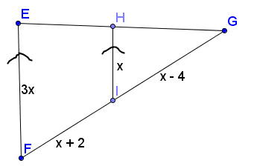

31. Find the area of the kite JMLK to the nearest tenth.

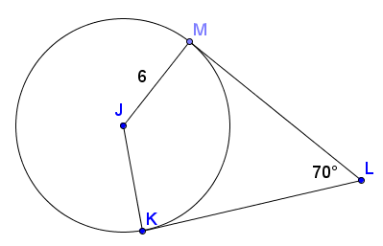

32. Write the equation of a line with a slope of 0.

33. Write the equation of a line with an undefined slope.

34. Find the measure of angle NPO given NQPO is a rectangle.

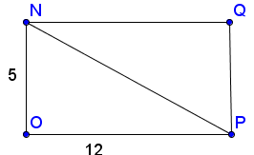

35. A flagpole creates a shadow of 25 feet where the angle of elevation of the sun is 38o. How tall is the flagpole?

36. Find the lengths of all sides in the triangle below. Then, find the area.

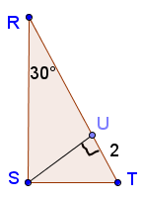

37. Find the range of possible side lengths of a third side of a triangle given the other two side lengths are 42 and 61.

38. Are their similar triangles in the figure below? If so, what shortcut proves they are similar and write a similarity statement.

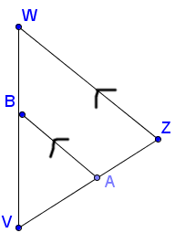

39. Find the lateral area and the total surface area of the regular hexagonal pyramid below, if the length of one side of the hexagon is 6 and the slant height of the pyramid is 18.



40. The silo of a barn, which consists of a cylinder and a hemisphere, needs to be repainted. In order to know how much paint to buy, you must find the total surface area of the silo. What is the total surface area?

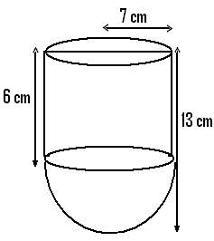

22

14