*** If this is not collected in the campus center, please bring it to next class***

Name: ____________________________________________________ Period:________ Date:____________________
Cumulative Review Worksheet
Rewrite the conditional statement in if-then form.
1. I will go to the game if I get all of my homework done.

2. A student on the high honor roll has at least a 90 average.

Write the converse, inverse and biconditional of each statement.
6. If you like surfing, then you like to be at the beach.

7. If angle P is 109 degrees, then angle P is obtuse

Rewrite the biconditional statement as a conditional statement and its converse. Then decide if the biconditional is true or false.
8. An angle is acute if and only if it measures less than 90 degrees.

9. Three points are collinear if and only if they lie on the same line.

10. Mark the figure to indicate the following information.
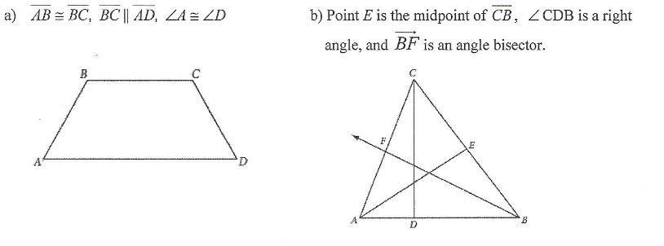
11. On a separate piece of paper, write algebraic proofs for the following equations.

12. Find the measure of each angle.
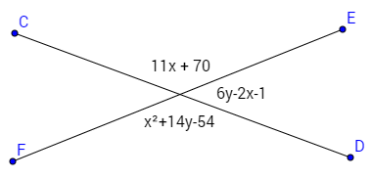

13. Brenda has just been hired as a plumber’s assistant. Her first task is to open all the water valves to release the pressure on the lines. She notices that the first four valves open by turning counterclockwise. She conjectures that all water valves open by turning counterclockwise. Is this inductive or deductive reasoning?

14. Find the missing angles.
