Chapter 5 Review

5.1 – Identities: You need to know the 8 fundamental identities and how to apply the 10 commandments (of identities.

5.2, 5.3, 5.4 – Sum, Difference, Double Angle and Half Angle Formulas.

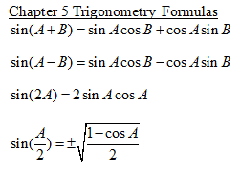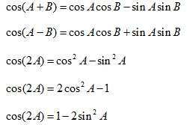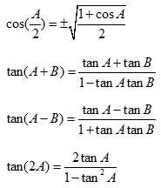

For 1 – 4, prove the identity.

1) 

2) 

3) 

For 4 – 7, Evaluate

4) tan(165) 5) csc(15)

6)  7) cos2195 – sin2195

8)  with A in QIV and  with B in QII, find:

1.  b. 

c.  d. 

9) Graph 