DUE MONDAY 12/1! Will be checked.
Name: _________________________________ Geometry Thanksgiving
Who is not hungry at Thanksgiving?
A | Point | N | 1/5
B | 55° | O | (4, 5)
C | 5 | P | Isosceles
D | 90 < x < 180 | Q | Vertical Angles
E | Perpendicular Bisector | R | (2, 1)
F | Rotations | S | Remote Interior Angle
G | x > 90 | T | -3/2
H | Scalene | U | Corresponding
I | Adjacent | V | 18
J | 145° | W | Deductive
K | Congruent | X | Angle Bisector
L | Linear Pair | Y | Supplementary
M | 3/2 | Z | Line
1) Slope of a line through (3, 4) and (2, -1) .
2) Midpoint of a segment with endpoints (6, 6) and
(-2, -4).
3) A triangle with all different side lengths.
4) The measure of an exterior angle of a triangle is equal to the sum of the linear pair and ______.
5) The range for an obtuse angle, x.
6) Two lines are parallel if the consecutive interior angles are…?
7) The complement of 35° is…?
8) Two adjacent angles that are supplementary.
9) Translations, reflections, and ___________ are called isometric transformations.
10) Corresponding angles are _____ if two parallel lines are cut by a transversal.
11) Slope of a line perpendicular to the line .
12) The most basic building block of Geometry.
13) Two triangles are congruent if their ________
sides and angles are congruent.
14) The line of reflection is the __________ of the line segment with endpoints P and P’.
_____ _____ _____ _____ _____ _____ _____ _____ _____
11 3 14 11 13 2 10 14 6

_____ _____ _____ _____ _____ _____ _____ _____ _____ ‘_____
7 14 1 12 13 4 14 3 14 4
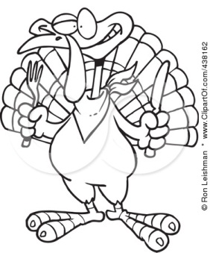
_____ _____ _____ _____ _____ _____ _____
12 8 2 14 12 5 6

_____ _____ _____ _____ _____ _____ _____!!!!
4 11 13 9 9 14 5
Why didn’t the skeleton turkey cross the road?
Directions: Solve each system of equations by using the elimination method. If you do not know what that is, youtube search “scevola systems of equations” and skip to minute 5:50.
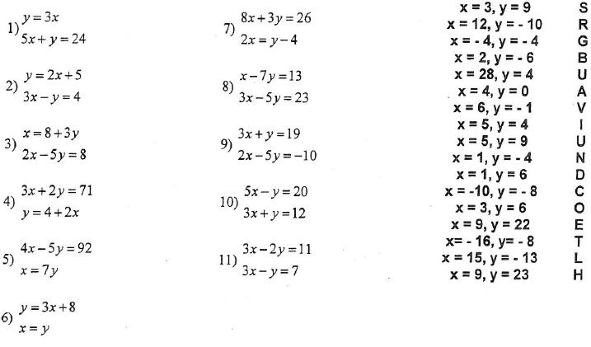

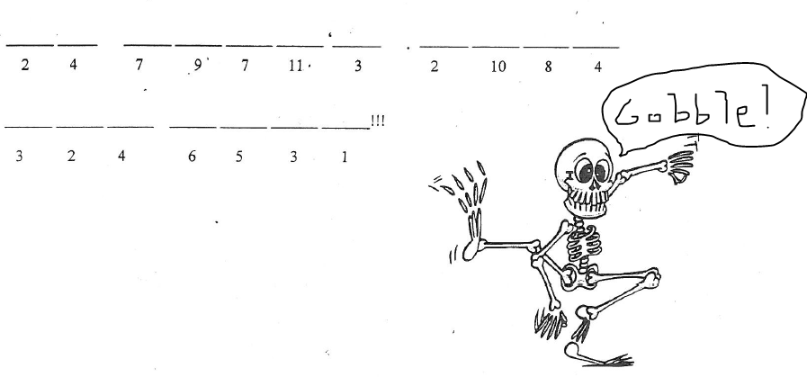
Reminder: Get this done by Monday 12/1. Have a nice Thanksgiving!

