**5.2 Practice Problems**

*Triangles, Triangle Sum Theorem, Exterior Angle Theorem, Congruent Triangles*

1. Identify all pairs of corresponding congruent angles and sides for each pair of congruent polygons. Then, write two different congruence statements for the polygons.

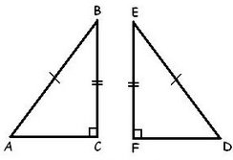

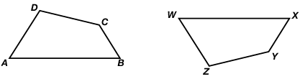



2. Given: , , , Find: DF and .

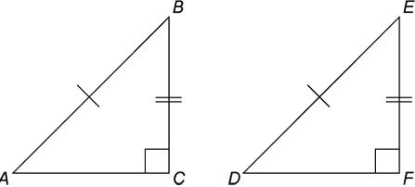

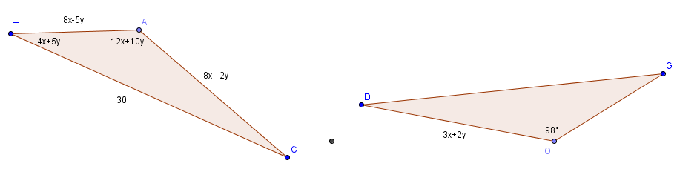3. Given, find the measure of angle C and segment GO.

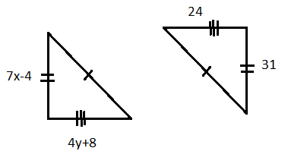4. Solve for x and y.

5. Find the measure of angle B.

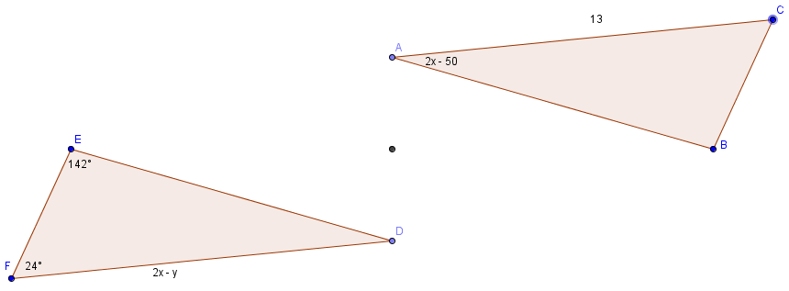

6. Classify $∆ABC$ with vertices A(-2, 3), B(0, -3), and C(3, -2) by its sides. Determine if it’s a right triangle.

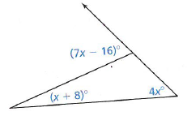7. Find the measure of the exterior angle.

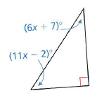

8. Find the measures of the acute angles.

9. Find the measure of one acute angle of a right triangle if it is 3 times the sum of the measure of the other acute angle and 8.

10. Find the measure of one acute angle in a right triangle if it is twice the difference of the measure of the other acute angle and 12.

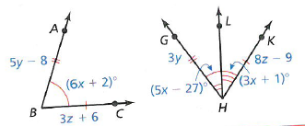11. Solve for x, y and z.

12. Given , E is the midpoint of and , , Prove .

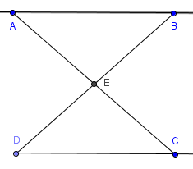

13. Given , solve for x and y.

14. Given , solve for x and y.

15. Find the missing numbered angle measures.

