Name:_________________________________________________
6.1 Perpendicular and Angle Bisectors Practice Problems
1) Find the range of side lengths for a triangle with side lengths 8x and 5x.

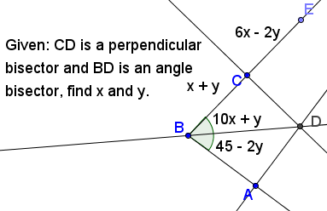

2)

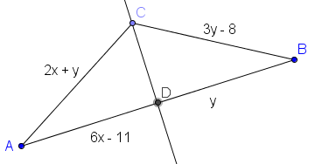
3)

4) Write the equation of the perpendicular bisector of the segment with endpoints (13, -7) and (21, -11).

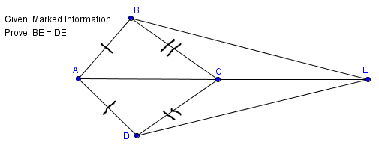
5.

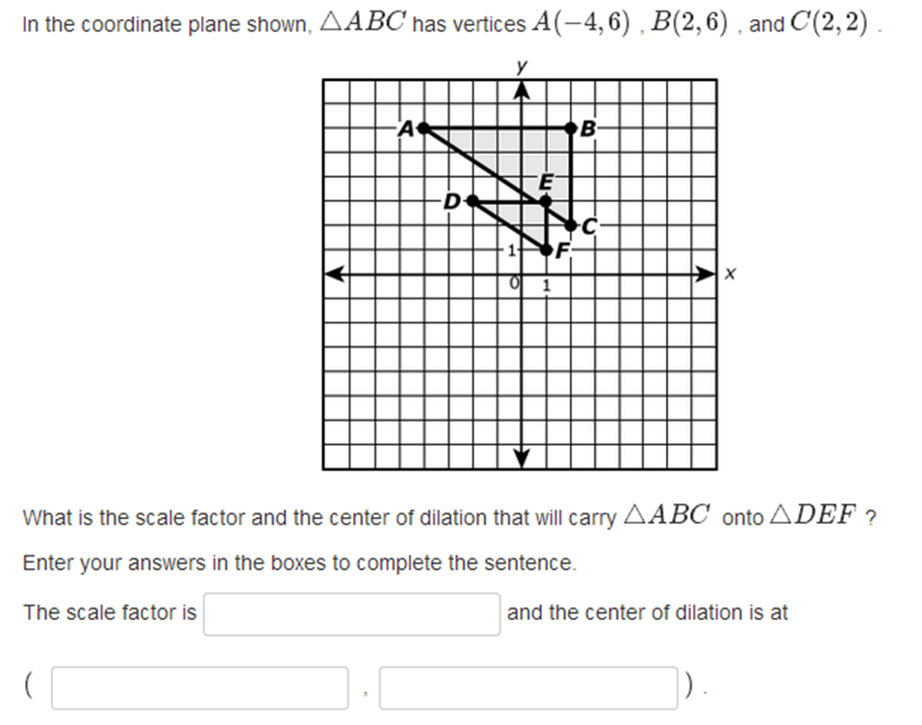
6. Prove (the converse of the Perpendicular Bisector Theorem) that if a point is equidistant to the endpoints of a line segment, it lies on the perpendicular bisector of that segment. Hint: There exists exactly one line through a point perpendicular to a line.
7.

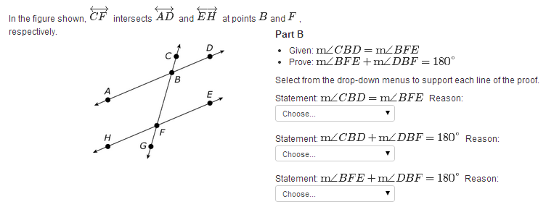
8.

