Name:__________________________________________________ Period:________ Date:________________________

5.5 Using Congruent Triangles

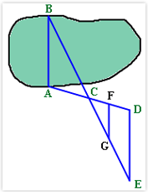1. A surveyor wants to measure the width of the lake pictured below, the distance from point A to B. He starts at point A and shoots a laser to point B, creating segment AB. He then walks along the river towards point D, creating a 100 degree angle BAD. Half way to point D, he places a marker at point C. After reaching point D, he then walks 150 yards away from the lake towards point E. At point E, he shoots a laser through points C and B, such that it creates an angle DEC measuring 30 degrees and angle DCE measuring 50 degrees. What is the length of the lake?

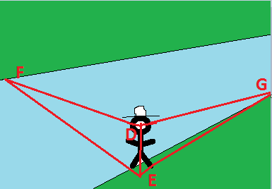2. It was reported that one of Napoleon’s officers estimated the width of a river as follows. The officer stood at the bank of the river and lowered the visor on his cap until the farthest thing visible was the edge of the bank on the other side. He then turned and noted the point on his side that was in line with the tip of his visor and his eye. The officer then paced to that point counting the distance from where the officer was to that point and concluded that distance was the width of the river. A) Explain how the officer came to his conclusion.

B) Prove segment FE = Segment EG, given angle DEG is a right angle, angle DEF is a right angle, angle EDG = angle EDF.

3. Prove , given all marked information.

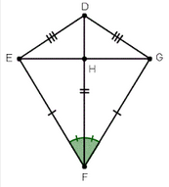

4. Prove , given marked information.

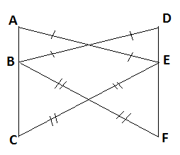

5. Prove , given marked information.

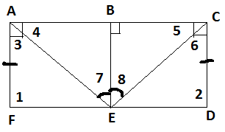

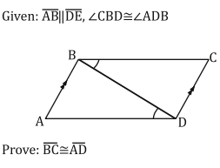

6.