Solving Triangles Flow Chart
The triangle is…..

Right Oblique

Given…
Two sides, to find the third do ______________________________

One side, to find the second do _____________________________

Two angles, to find the third _______________________________ Case…

One angle, to find the third do ______________________________

ASS
AAS, ASA SSS, SAS

Do__________________________ Do_______________________
The given angle is…

KEY: Ag = Given Angle, So = Side Opposite Given Angle,
Sa = Side Adjacent Given Angle, H = Height
Obtuse Acute
Compare So to Sa Compare So to Sa
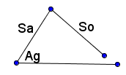
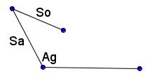

I) If So < Sa, then there are _______ possible triangles. I) If So > Sa, there is _______ possible triangle
II) If So < Sa, find the height and there are three cases.
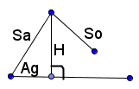
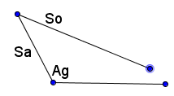 Compare So to H
II) If So > Sa, then there is ________ possible triangle. If So < H, there are _______ possible triangles.

If So = H, there is _______ right triangle.

If So > H, there are _______ possible triangles.

For Ambiguous Case ASS, use __________________ to find missing sides and angles.

