Chapter 4 Review Problems

**4.7** **Inverses**

Find the angle in degrees without a calculator.

1)  2)  3) 

4)  5)  6) 

Find the angle in degrees with a calculator.

7)  8)  9) 

Find the angle in degrees and make sure to provide a picture.

10)  11) 

12)  13) 

14) 

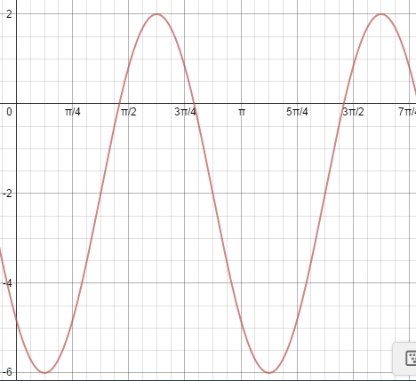15) Write the equation of the for the graph starting at x = , x =, x = .

16. Graph  over two full periods.

17. Graphover two full periods.