Chapter 4.1 Graphing Trigonometric Functions
Fill out the table with exact values.
x (Deg) | 0 | 30 | 45 | 60 | 90 | 120 | 135 | 150 | 180 | 210 | 225 | 240 | 270 | 300 | 315 | 330 | 360
x (Rad)
sin(x)
cos(x)

Graph the sin(x) over the interval [0, 2π]. Then use the fact that sine is odd to graph it over [-2π, 0].
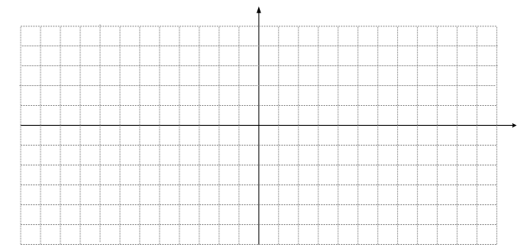
f(x) = sin(x)

Graph the cos(x) over the interval [0, 2π]. Then use the fact that cosine is even to graph it over [-2π, 0].
f(x) = cos(x)

What do you notice about the graphs of sine and cosine?

Sinusoidal Axis – The horizontal line on which the graph “hangs”. For f(x) = sin(x) and g(x) = cos(x), the sinusoidal axis is y = 0. Just like in algebra, f(x) + D shifts the graph vertically D units.
Graph the following:
f(x) = sin(x) + 3 g(x) = cos(x) + 7
f(x) = sin(x) -4 g(x) = cos(x) -5
Each of the following was of the form f(x) = sin(x) + D and g(x) = cos(x) + D. In general how do you find the sinusoidal axis from the equation?

Graphs of sine and cosine rise to a maximum then descend to a minimum.
Amplitude – The maximum distance the graph gets from the sinusoidal axis.
(not the distance between the maximum and minimum).
Just like in Algebra, -f(x) flips f(x) over the x axis.
Graph the following. Pay attention to the amplitude and if the graph heads uphill or downhill from (0,0).
y = 3sin(x) y = 4cos(x)
y = -2sin(x) y = -2cos(x) - 3
y = 4sin(x) + 3 y = -5cos(x) + 1
Each of the functions was of the form y = Asin(x) + D and y = Acos(x) + D. What does the value of A tell you about the graph?

How can you find the y-value of the maximum and minimum of the graph in terms of A and D?

Period – The subset of the domain in which the range cycles before it repeats. Sine and cosine have a period of what?

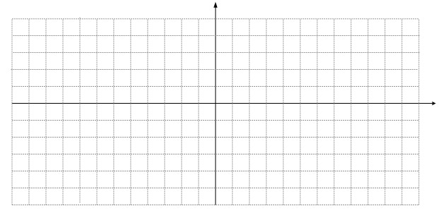
Graphing sin(x) and cos(x) Practice

1) y = 3sin(x) – 2

A = ____________

B = ____________

Period = ________

S.A.: y = ________

Domain: _______

Range : ________
2) f(x)= 2cos(x) + 1

A = ____________

B = ____________

Period = ________

S.A.: y = ________

Domain: _______

Range : ________
3) y = -2sin(x) + 4

A = ____________

B = ____________

Period = ________

S.A.: y = ________

Domain: _______

Range : ________

4) g(x) = cos(x) + 4

A = ____________

B = ____________

Period = ________

S.A.: y = ________

Domain: _______

Range : ________
5) y = -3cos(x) - 4

A = ____________

B = ____________

Period = ________

S.A.: y = ________

Domain: _______

Range : ________
6) y = 3sin(x) + 1

A = ____________

B = ____________

Period = ________

S.A.: y = ________

Domain: _______

Range : ________
HW: 7)y=4sin(x)-2 8)y=-2cos(x) 9)y=(1/2)sin(x) 10)y = -2sin(x) – 4 11)y=6cos(x)-1

