**Name:**

11.

12.

13.

14.

**3.1 Homework – Identifying Pairs of Angles**

**Directions: Type your answers into the textboxes provided**.

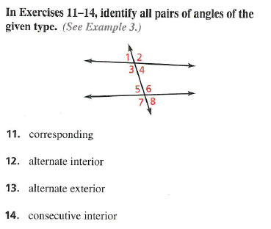

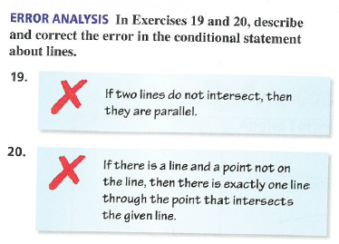

19.

20.

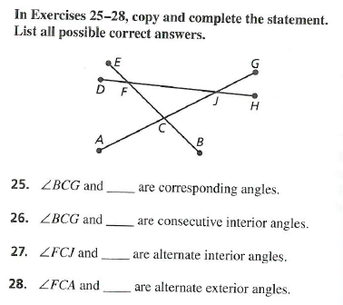

25.

26.

27.

28.

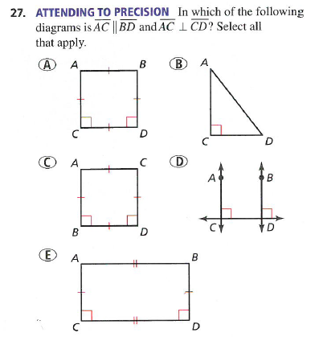

27.

