Name:____________________________________________________ Period:_________ Date:_____________________
Systems of Equations Homework
Solve each system using any algebraic method. Be sure to plug your answers back into both equations to check your work.
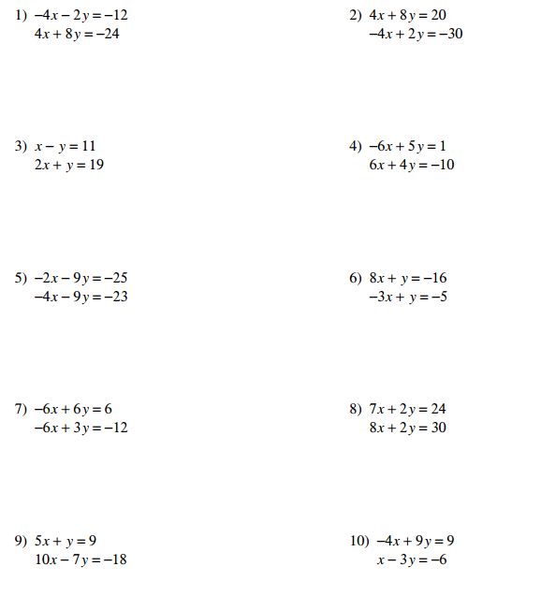

(more on the back)
