2.1: Unit 2, Chapter 1 – Angles, Right Triangles, Radicals
Notes
Draw a picture of each in standard position. Label the angle and name the vertex, terminal side and initial side.
Acute Angle Obtuse Angle Right Angle Straight Angle

Complementary – Adds to____________________ Supplementary – Adds to _______________________

Prove the Pythagorean Theorem.
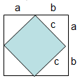

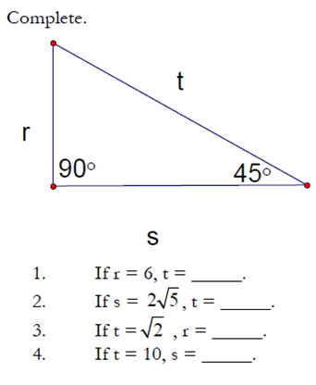
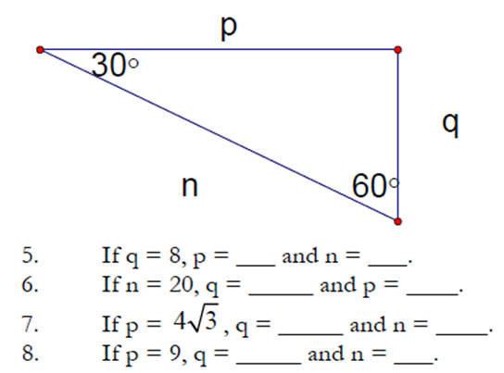

Solve for x.
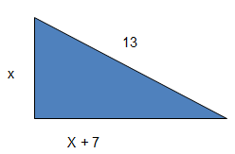

A ladder is leaning against a wall. The top of the ladder is 4 feet above the ground and the bottom of the ladder makes an angle of 60º with the ground. How long is the ladder and how far from the wall is the bottom of the ladder?

