Name:__________________________________________________________________ Period:_______

**14.2 Linear Systems and Matrices**

Use matrix multiplication to write each system represented by the matrix equation.

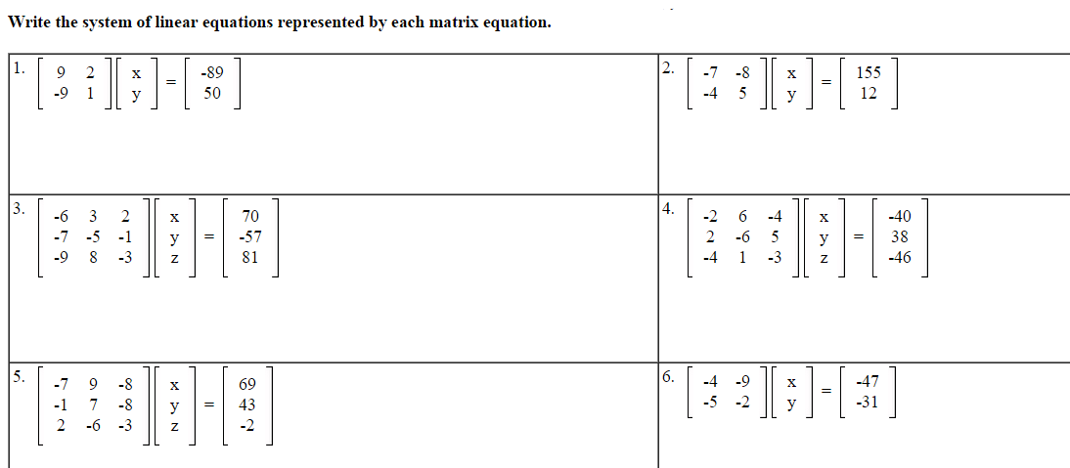

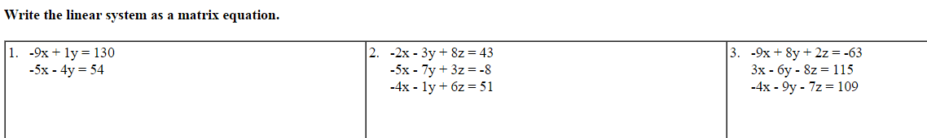

**A** Solving systems with inverses

Just multiply each left side by the inverse of the coefficient matrix.

You must do it by hand for a 2x2 and with a calculator for a 3x3 or more.

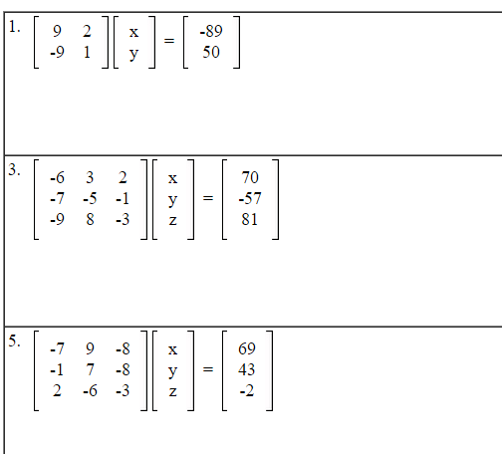

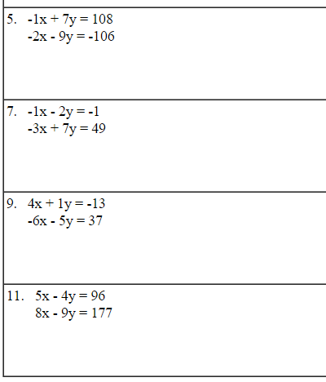

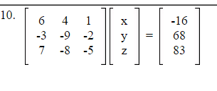

RREF – Reduced row echelon form.

It is a function in linear algebra that will solve the system for you when using your calculator.

Just type rref(A) where A is the coefficient matrix with the constants as the last column.

You can use it on a test to check your work, but you will only get credit for showing the steps of either the inverse method or Cramer’s rule.

**B** Cramer’s Rule

Let’s solve the system with Cramer’s rule.



Step 1, find:

D- Determinant of the coefficients



- Determinant of the coefficients when the coefficients of x are replaced with the constant terms



- Determinant of the coefficients when the coefficients of y are replaced with the constant terms



Step 2: x =  y = 

Solve each system using Cramer’s rule by hand if it is a 2x2 and with a calculator if it is a 3x3.

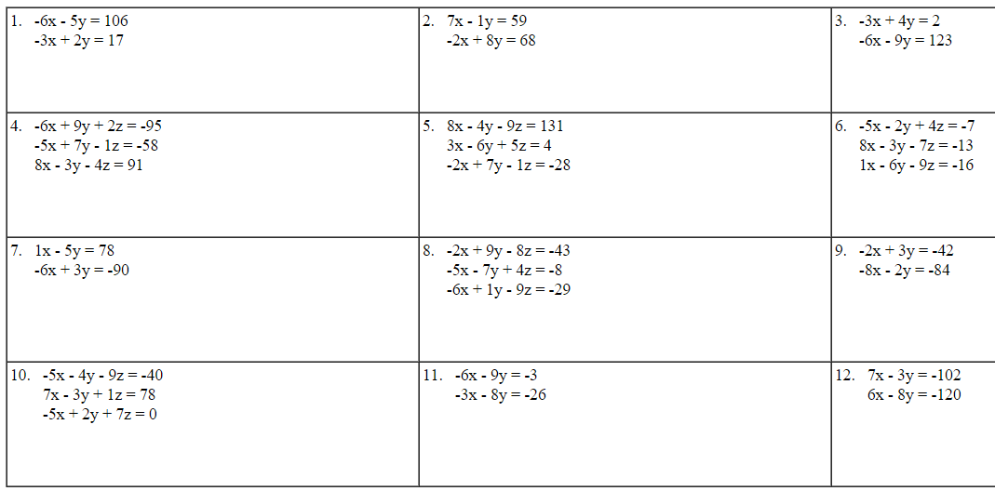

**C** Finding the area of triangles using matrices.

