Name:_________________________________________________________ Period:_______

**Matrices, Section 1: Basic Matrix Operations**

Directions: Learn how to do everything in this packet by hand and with a calculator. Check your work with a calculator.

Rows – The vertical array(s) of a matrix

Columns – The horizontal array(s) of a matrix.

Dimension – Rows x Columns

**A)** Write the dimensions of each matrix.

1. 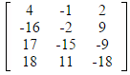 2.  3.  4.  5.

**B)** Matrix Addition and Subtraction.

You can only add/subtract matrices with the same dimensions.

Add/Subtract each element in the corresponding positions.

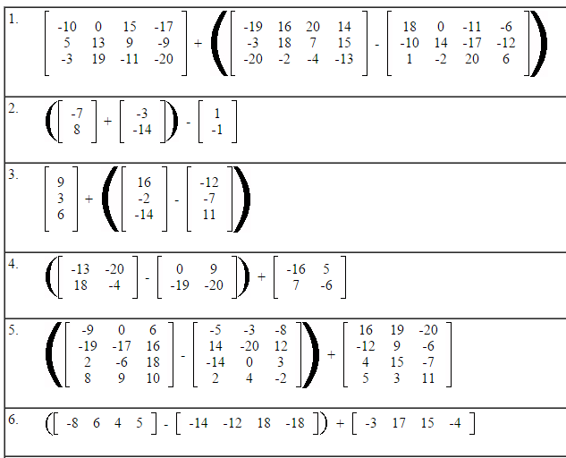

**C** Scalar Multiplication

This is different from matrix multiplication (we will learn about that later).

Just multiply each element by the number outside the matrix.

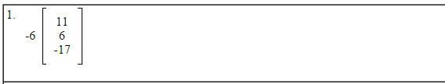

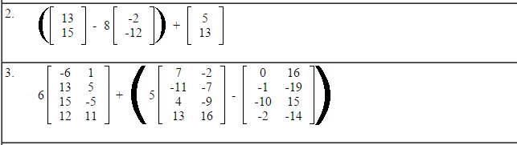

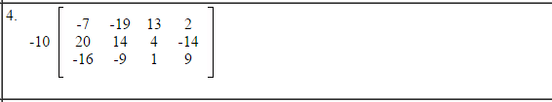

**D** Solving for x

Just work on the elements in the same positions of the variables.

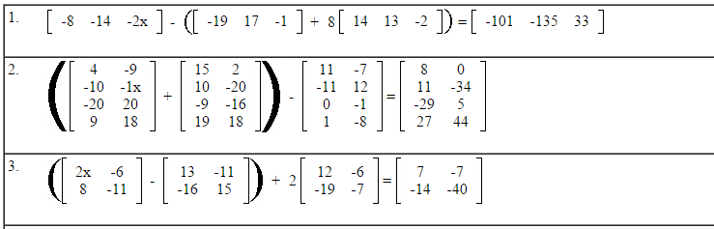

**E** Matrix Multiplication

To multiply two matrices, the number of columns in the left matrix must equal the number of rows in the right matrix.

The product will have the dimensions “rows in left matrix” x “columns in right matrix”.

The element a1x1 (first row, first column) will equal the sum of each element of the first row of the left matrix multiplied by each element of the first column of the right matrix.

In general, amxn will equal the sum of each element of row m of the left matrix multiplied by each element of column n of the right matrix.

Let’s do some together.







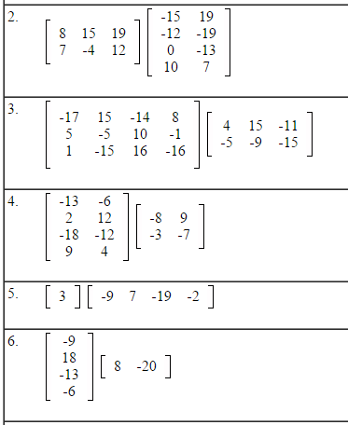

**F** Transposing a Matrix

At means to transpose matrix A.

Transpose means to switch row 1 with column 1, row 2 with column 2…

Transpose each matrix.



**G** Finding the determinant of 2x2 matrices

A determinant is a value associated with square matrices that has many useful applications, but for now, we will just calculate determinants of 2x2 matrices by hand.

The notation for the determinant of a matrix A is: 1. 2. 3. 

The definition of det(A) given is 

That’s right, all you do is multiply the upper left element by the lower right element and subtract the product of the other two elements.

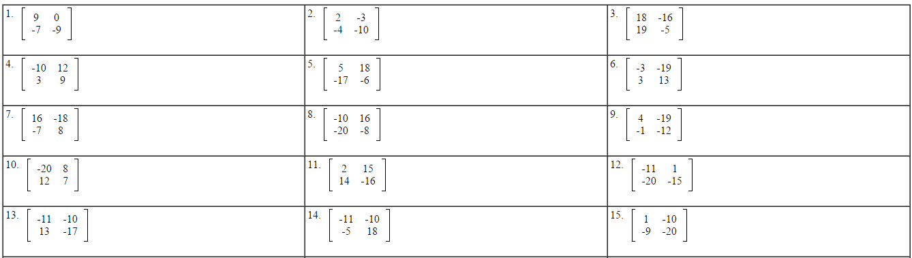

**H** Inverses of 2x2 matrices

If , then .

That -1 exponent means inverse.

Only square matrices have inverses.

You will only be asked to find the inverse of 2x2 matrices by hand.

If |A| = 0, then A is not invertible (meaning, has no inverse).

Let’s try some together.

 

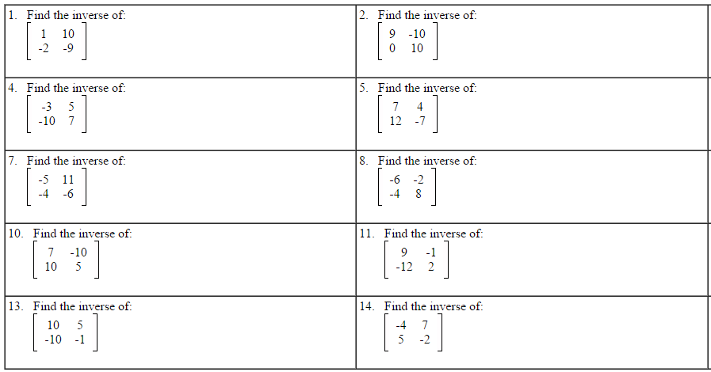

**I** Solving for matrices.

Just like solving a linear equation, you do inverse operations to solve for a variable matrix.

The biggest difference is that you cannot divide matrices. Instead, multiply by an inverse matrix.

Matrix multiplication is not commutative (unlike multiplication of real numbers), so if you multiply matrix A on the left on one side of the equation, you must multiply it on the left on the other side of the equation.

Let’s do one together.



