Honors Geometry: 1.4 Perimeter and Area in the Coordinate Plane
Directions: Please answer these questions on a separate piece of paper.
1. The lines y₁ = 2x – 6, y₂ = - 3x + 4, y₃ = - $\frac{1}{2}$x + 4 are the sides of a right triangle.
a) Use slopes to determine which sides are perpendicular.
b) Find the vertices of the triangle.
c) Find the perimeter and area of the triangle.
2. Plot the points Q(-1,2), U(3,2), A(-1,-2), D(3,-2).
a) Find the perimeter and area of the square.
b) Connect the midpoints of the sides of the given square to make a quadrilateral. Is this quadrilateral a square? Explain your reasoning,
c) Compare the perimeter and area of the quadrilateral you made in parts (a) and (b).
3. Solve for x. $\frac{x+1}{2}$ = 4x – 3
4. What is the difference between a postulate and theorem? 5. |x – 4| = 5
6. Find the measure of angle WST.
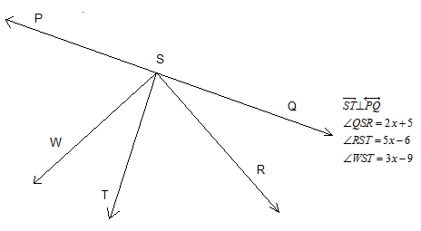

7. Your aunt decides she would like to install a rectangular swimming pool in your backyard which has dimensions of 20ft by 15ft. Instead of hiring a professional, she assigns you to the job because she knows with your prodigious math skills, you could handle it. Also, it will save her a ton of money. She requests a 3-foot edge around each side of the pool. Draw a diagram of this situation in a coordinate plane. What is the perimeter and area of the largest swimming pool that will fit?
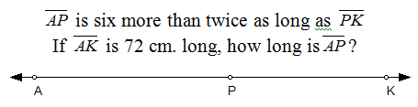
8. Referring to the previous problem, your aunt now doesn’t know if a 3 foot edge is the right amount. Come up with an expression in terms of x, where x is the length of the edge, for the perimeter and area of the swimming pool.
9.

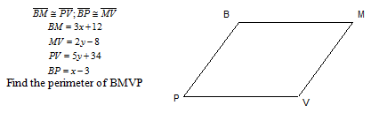
10.

11.

12. Find the midpoint between the points (3/4, -2/7) and (5/3, -5/3)
13. Solve for x.
14. Find the area and perimeter of a triangle with vertices C (-5, 2), A(11, 2) and (15, -7).
15. Find the area and perimeter of the rectangle with vertices S (-3, 4), C(1, 4), E(-3, -2), V(3, -2).
16. Sketch two lines that intersect a plane at one point.

